Instructions for Stock Certificates and Ledger Templates

Open the template. You will get a “Security Warning” message. Click the “Options” Button.

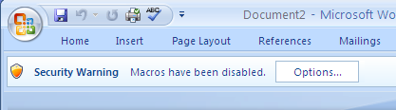

In the Microsoft Office Security Options Dialogue Box, select “Enable this content” and click the OK button. You can always trust content from Bindertek.

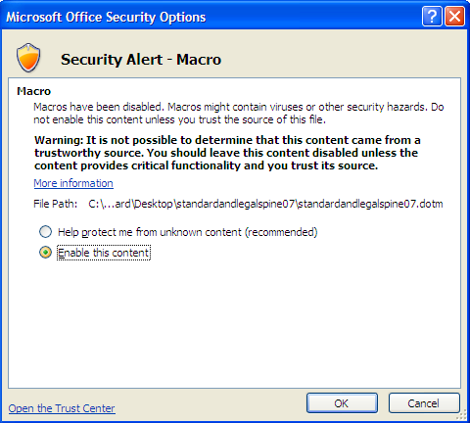

Type your text in the fields provided. The template is pre-formatted for the best fit.

NOTE: If you encounter a Run Time Error 4120 message when using the Stock Certificate templates, you may have to adjust your Microsoft Word settings. Visit http://support.microsoft.com/kb/948682 for Run Time Error 4120 instructions, if needed.

Print and save your templates.

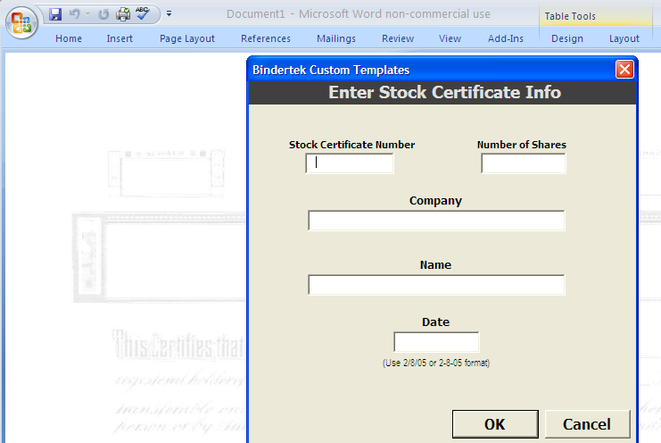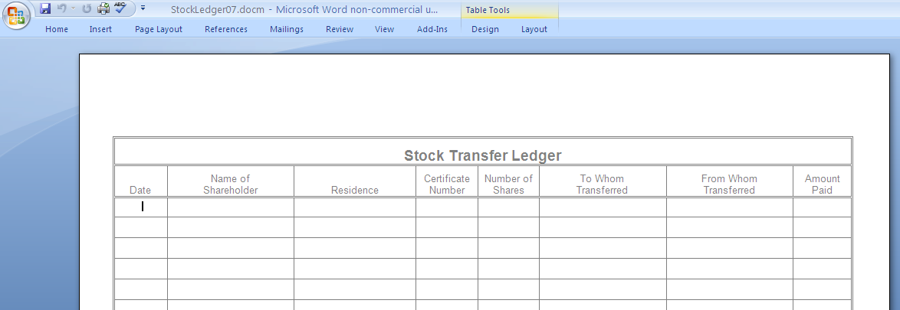

_____________________________________________________________________

Questions? We’re here to help. Call 800.456.3453 or email info@bindertek.com

